

PRODUCTY SAAS - PRODUCT HUNT

Next js web app for promoting products

contact
mail: fistrba@gmail.com
telegram: t.me/fistrba



Content
How to run it locally
Auth
SAAS
Products
Admin
Contact

'

How to run it locally (http://localhost:3000)

- open main folder in VISUAL STUDIO CODE
- open terminal and type npm install
click here for video
(https://drive.google.com/file/d/1ikDWVX0CcJPDKevpkA-tTAEnS2OS4tHs/view?usp=drive_link)
- open .env and add there all API KEYS
3.1 GITHUB
go to the github.com to your account
go to settings > developers settings
go to OAuth Apps
Click on New OAuth App
give name, des
Home page url: http://localhost:3000
Authorization callback URL: http://localhost:3000/api/auth/callback/github

After that you will see client_Id and client_secret
and this you need to add to .env
click here for video
(https://drive.google.com/file/d/1Mi0TMDsVgZ9glO_vJwbCENBkJGihmx_B/view?usp=sharing)

3.2 GOOGLE
go to google.console
create new project
and follow the video and create credentials API
and add google_id and google_secret to .env
click here for video (https://drive.google.com/file/d/1BkWNksYQBqsKoCF6kUS1WCqDOIR7ZpyM/view?usp=sharing)

3.3 DB
go to https://neon.tech
and create account
create project and add db api to .env

3.4 UPLOADTHING
go to https://uploadthing.com
and create account
create project and add db api to .env

3.4 STRIPE
go to https://stripe.com
login
switch test mode
add stripe secret api
and go to terminal
type: stripe login
after that:
stripe listen --forward-to http://localhost:3000/api/stripe

after that add webhook secret to .env

3.4 ADMIN
admin-name
password for admin account

- if you have all .env api you can type: npm run dev
- (http://localhost:3000)

Auth

Secure and Simple Authentication in Producty
At Producty, we've made logging in both secure and convenient with our Next.js web app. Users can securely log in using Google or GitHub authentication, leveraging the trusted OAuth 2.0 protocol.

Google Authentication:
Convenience: One-click login with Google accounts.
Security: Google manages the authentication, providing multi-factor authentication and robust security.

GitHub Authentication:
Developer-Friendly: Perfect for developers, aligning with their tools.
Security: Utilizes GitHub’s strong security features, including two-factor authentication.
Security Features:

OAuth 2.0 Protocol: Ensures secure handling of credentials.
Encrypted Communications: Protects data with HTTPS.
Token-Based Authentication: Keeps users logged in securely.

Our user-friendly interface makes logging in quick and intuitive, enhancing your overall experience with Producty.

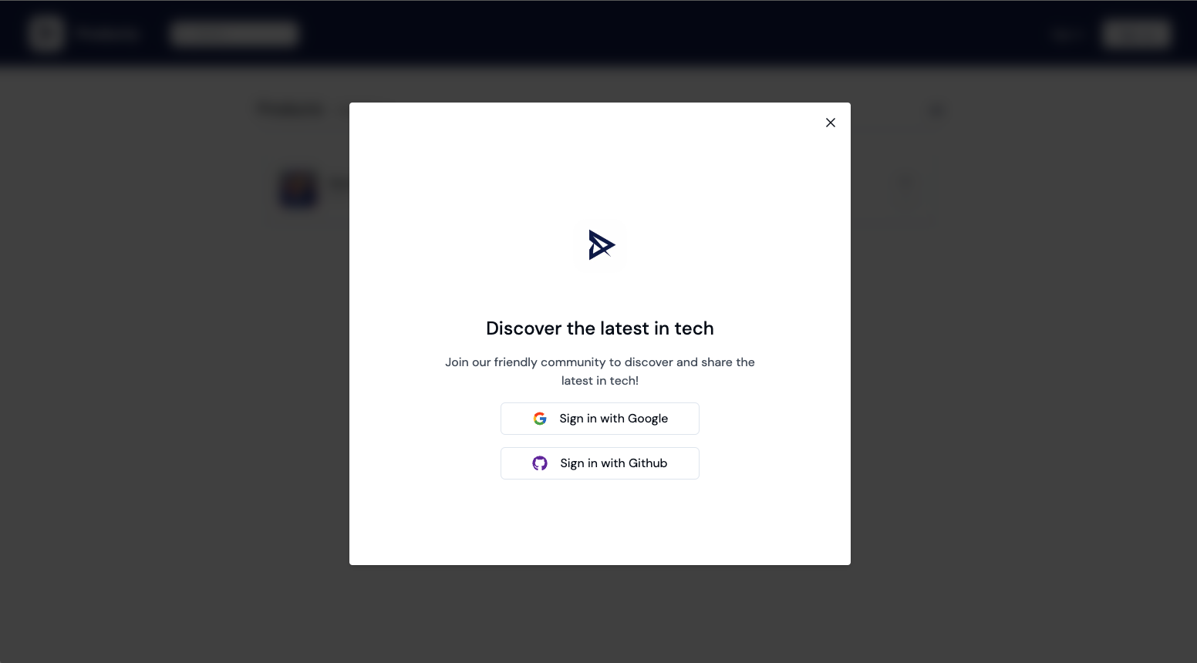

SAAS

At Producty, managing your projects and subscriptions is effortless, thanks to our integration with Stripe for payment processing. Here's how we ensure a seamless experience:

Stripe Integration:
Ease of Use: Stripe handles all payment processes smoothly, allowing you to manage subscriptions without hassle.
Recurring Payments: Automate billing for your customers, ensuring they have uninterrupted access to your services.
Transaction History: Easily track and review all transactions, providing transparency and cont
rol over your finances.
Customer Billing Management: Update payment methods, handle disputes, and manage customer accounts all in one place.

Flexible Plans:
Free Plan: Add up to 2 products at no cost.
Premium Plan: Upgrade for unlimited submissions and extra features, enhancing your productivity and capabilities on Producty.

With Stripe's secure and reliable system, you can focus on growing your business while we take care of the payments.

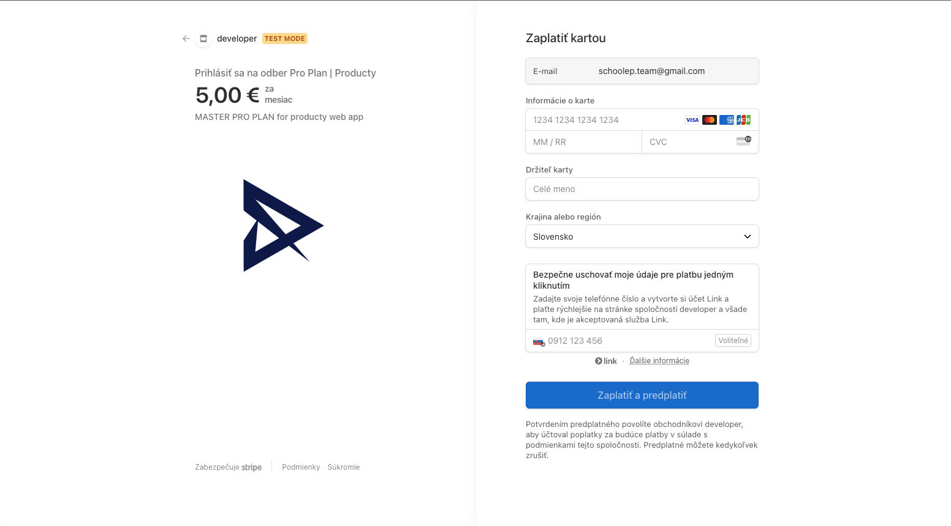

Products

Producty is designed to help you showcase your products to the world through Product Hunt. Here's how it works:

Add and Submit Your Product:

Easy Submission:
Quickly add your product to our platform and submit it for review.
Publishing: Once approved, your product goes live for the community to explore.

Engagement and Feedback:
- User Interaction: Visitors can explore your product, visit your website, and engage with your creation.
- Comments and Feedback: Users can leave comments and provide valuable feedback to help you improve.
- Upvotes: Community members can upvote your product, increasing its visibility and credibility.

Showcasing your products on Producty is a streamlined process that connects you with a wider audience, helping you gain the recognition and insights you need to succeed.

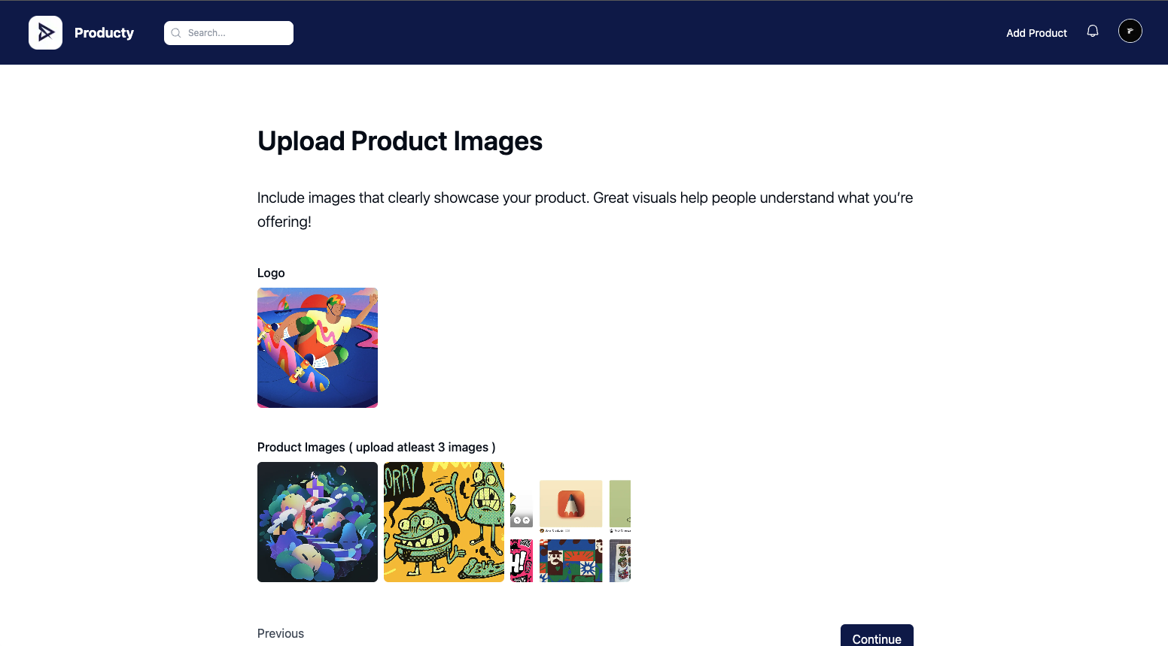

Admin

Our admin panel in Producty is designed to help you maintain a high-quality and organized platform. Here's what you can do:

Dashboard Overview:
- User Statistics: View the total number of users registered on the platform.
- Product Statistics: Monitor the number of products added and upvotes received.

Product Review Management:
- Pending Reviews: See a list of products waiting for review.
- Activation or Rejection: As an admin, you can review each product and decide whether to activate or reject it, ensuring only the best content is showcased.

By effectively managing users and products, our admin panel helps you maintain a robust and organized platform.

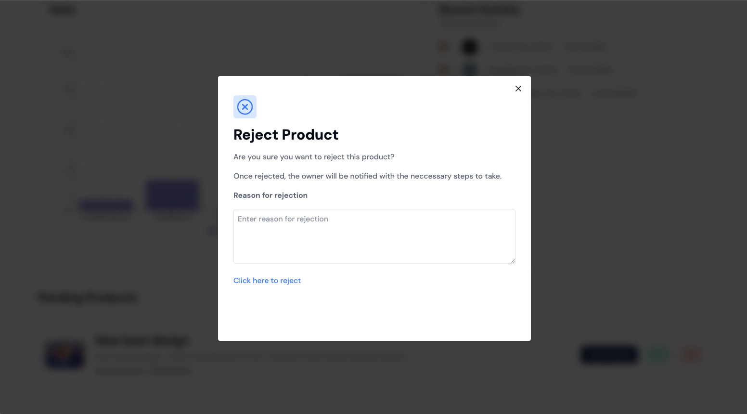

Contact

email: fistrba@gmail.com
telegram: t.me/fistrba

